Asia-Pacific Management and Business Application
10 (1) 1-10
©UB 2020
University of Brawijaya
Malang, Indonesia
http://apmba.ub.ac.id

Asia Pacific Management and Business Application
(APMBA)

Asia Pacific*

Faculty of Economic and Business, University of Brawijaya, Malang, Indonesia

Abstract
Asia Pacific Management and Business Application. Asia Pacific Management and Business Application. Asia Pacific Management and Business Application. Asia Pacific Management and Business Application. Asia Pacific Management and Business Application. Asia Pacific Management and Business Application. Asia Pacific Management and Business Application.
Asia Pacific Management and Business Application. Asia Pacific Management and Business Application. Asia Pacific Management and Business Application. Asia Pacific Management and Business Application. Asia Pacific Management and Business Application. Asia Pacific Management and Business Application. Asia Pacific Management and Business Application.

Keywords
Asia, Pacific, Management, Business, Application
Received: 10 February 2020; Accepted: 14 March 2020 Published Online: 29 April 2020

Introduction
Asia Pacific Management and Business Application. Asia Pacific Management and Business Application. Asia Pacific Management and Business Application.
Asia Pacific Management and Business Application. Asia Pacific Management and Business Application. Asia Pacific Management and Business Application.

Asia Pacific Management and Business Application. Asia Pacific Management and Business Application. Asia Pacific Management and Business Application.

Table Example:

Table 1. Asia Pacific Management and Business Application

Asia Pacific Index | Management | Business
Chi-square ( X2) | < 62,50 | 13,05576 | Fit
Probability | > 0,05 | 0,097 | Fit
RMSEA | < 0,08 | 0,030 | Fit
GFI | > 0,90 | 0,945 | Fit
AGFI | > 0,90 | 0,8930 | Marginal Fit
CMIN/df | < 2,00 | 1,45064 | Fit
TLI | > 0,90 | 0,96513 | Fit
CFI | > 0,95 | 0,99236 | Fit
Source : APMBA

Figure Example:

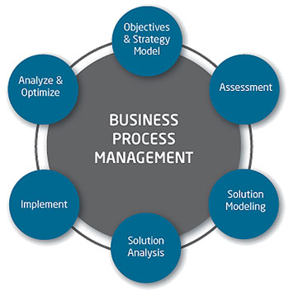

Figure 1. Asia Pacific Management and Business Application

Notes on Contributor

Asia Pacific is a senior lecturer in Magister Management Program, University of Brawijaya. His research interest are Financial management, Risk Management, Good Governance, Audit Forensic, strategic management, Capital market.

References

Asia, Pacific. (2012). Asia Pacific and Business Application. International Journal of Asia Pacific and Business Application Vol. 3 No. 3.
Business, Application, (2013), Asia Pacific and Business Application, 1st Ed, Prentice Hall, USA.

